# HW-3 – Relational Algebra

Database: Henry.rdb (WinRDBI database)

Use WinRDBI to create your relational algebra queries. For each question below, provide the text of your relational algebra queries (copy and paste the text), along with a screen image of the tuples in the final result. Submit your results as a Word document into Canvas.

*Remember that you must derive everything from the database, using only the values given in the questions. You may not look up a value manually and hard-code that into your query.*

1. List the author number and last name, the book code and title, for all authors who have written at least one non-paperback book.

auth:= project authorNum, authorLast(author);

npb:= select paperback='N'(book);

authorsWroteNPB:= wrote njoin npb ;

test:= authorsWroteNPB njoin auth;

answer:= project authorNum, authorLast, bookCode, title(test);

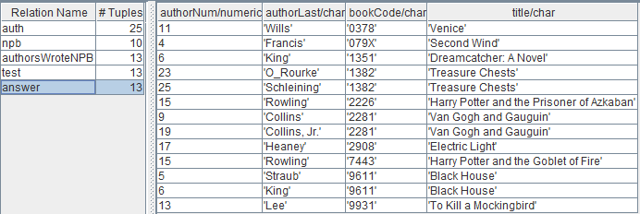

answer:= project authorNum, authorLast, bookCode, title((wrote njoin (select paperback='N'(book))) njoin (project authorNum, authorLast(author)));

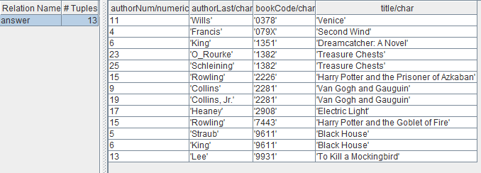

1. List author number and last name for all authors who have not written any books. (You must use the DIFFERENCE operator).

auth:= project authorNum (author);

wrot:= project authorNum (wrote);

dif:= auth difference wrot;

ans:= project authorNum, authorLast(author njoin dif);

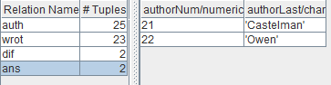

ans:= project authorNum, authorLast(author njoin ((project authorNum (author)) difference (project authorNum (wrote))));

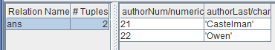

1. List the publisher code and publisher name for all publishers that have not published any books. (You must use the DIFFERENCE operator).

publishers:= project publisherCode(publisher);

published:= project publisherCode(book);

dif:= publishers difference published;

ans:= project publisherCode, publisherName(publisher njoin dif);

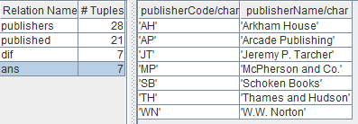

ans:= project publisherCode, publisherName(publisher njoin ((project publisherCode(publisher)) difference (project publisherCode(book))));

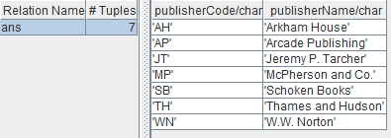

1. List the author number and last name, the book code and title, for all authors who have written at least one book that was published by Random House.

pub:= select publisherCode='RH'(book);

authorRH:= pub njoin wrote;

authorInfo:= author njoin authorRH;

ans:= project authorNum, authorLast, bookCode, title(authorInfo);

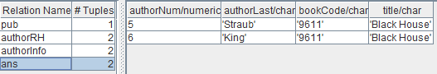

ans:= project authorNum, authorLast, bookCode, title(author njoin ((select publisherCode='RH'(book)) njoin wrote));



1. List publisher code and publisher name for all publishers who have published only paperback books.

paperBack:= project publisherCode(select paperback='Y'(book));

nonpaperBack:= project publisherCode(select paperback='N'(book));

dif:= paperBack difference nonpaperBack;

pubInfo:= dif njoin publisher;

ans:= project publisherCode, publisherName(pubInfo);

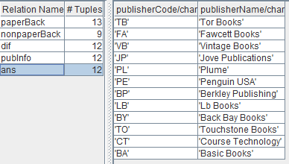

ans:= project publisherCode, publisherName(((project publisherCode(select paperback='Y'(book))) difference (project publisherCode(select paperback='N'(book)))) njoin publisher);

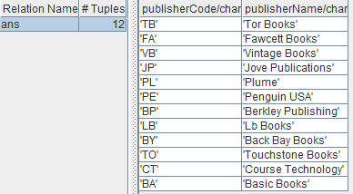

1. List the book code and title for all books for which there are more than one copy in the Henry Eastshore branch.

br:= select branchNum=4(inventory);

greaterThanOne:= select onHand>1(inventory);

joined:= br njoin greaterThanOne;

bookInfo:= book njoin joined;

ans:= project bookCode, title(bookInfo);

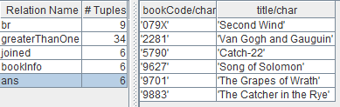

ans:= project bookCode, title(book njoin ((select branchNum=4(inventory)) njoin (select onHand>1(inventory))));

